

**PROJECT PROPOSAL OF**

**OPERATING SYSTEMS LAB**

|  |  |
| --- | --- |
| **NAME:** | **Rabia**  **Zainab-Binte-Hassan** |
| **ID:** | **FA17-BECE-2001**  **FA17-BECE-0020** |
| **TEACHER NAME:** | **Ma’am Rafia** |
| **SECTION:** | **BE(CSE)--AM** |
| **PROJECT TOPIC:** | **Sleeping Teaching Assistant** |

**INTRODUCTION:**

This project deals with solving the Sleeping Teaching Assistant problem using thread synchronization. The implementation involves defining approaches to be taken for different scenarios as to how a Teaching Assistant (TA) and students interact with each other. The solution will be implemented using POSIX threads, mutex-locks, and semaphores for the different scenarios.

**PROJECT DESCRIPTION:**

The project problems are solved by the team using POSIX threads, semaphores and a FIFO queue in order to describe the behaviors of the TA and the students. Both the TA and students will have their own semaphores and separate p-threads. . By using a mutex-lock the situation of a deadlock can be avoided as either the TA or the student will have exclusive rights to change their state and this can be accomplished by only one person at a given instance. By using a First-In First-Out queue, starvation can be avoided as we know every student will be served according to the time they arrive at the TA’s office. Therefore, no student will be able to skip the line. The team approaches the Teaching Assistant Problem by solving 4 different scenarios.

**FLOW CHART:**

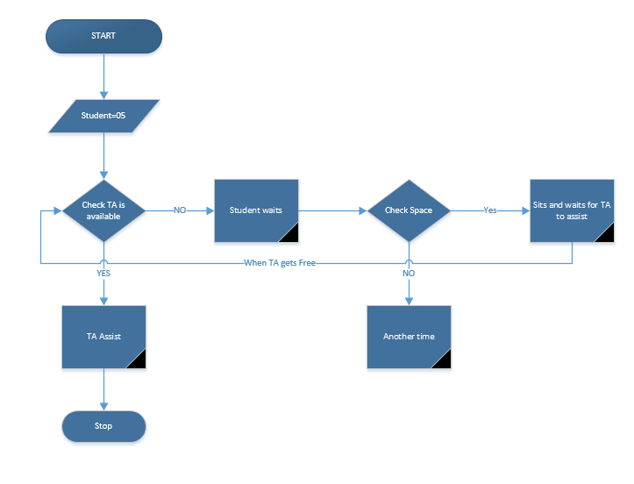

**PROJECT CODE:**

#include <pthread.h> //Create POSIX threads.

#include <time.h> //Wait for a random time.

#include <unistd.h> //Thread calls sleep for specified number of seconds.

#include <semaphore.h> //To create semaphores

#include <stdlib.h>

#include <stdio.h> //Input Output

pthread_t *Students; //N threads running as Students.

pthread_t TA; //Separate Thread for TA.

int ChairsCount = 0;

int CurrentIndex = 0;

//Declaration of Semaphores and Mutex Lock.

sem_t TA_Sleep;

sem_t Student_Sem;

sem_t ChairsSem[3];

pthread_mutex_t ChairAccess;

//Declared Functions

void *TA_Activity();

void *Student_Activity(void *threadID);

int main(int argc, char* argv[])

{

int number_of_students; //a variable taken from the user to create student threads. Default is 5 student threads.

int id;

srand(time(NULL));

//Initializing Mutex Lock and Semaphores.

sem_init(&TA_Sleep, 0, 0);

sem_init(&Student_Sem, 0, 0);

for(id = 0; id < 3; ++id) //Chairs array of 3 semaphores.

sem_init(&ChairsSem[id], 0, 0);

pthread_mutex_init(&ChairAccess, NULL);

if(argc<2)

{

printf("Number of Students not specified. Using default (5) students.\n");

number_of_students = 5;

}

else

{

printf("Number of Students specified. Creating %d threads.\n", number_of_students);

number_of_students = atoi(argv[1]);

}

//Allocate memory for Students

Students = (pthread_t*) malloc(sizeof(pthread_t)*number_of_students);

//Creating TA thread and N Student threads.

pthread_create(&TA, NULL, TA_Activity, NULL);

for(id = 0; id < number_of_students; id++)

pthread_create(&Students[id], NULL, Student_Activity,(void*) (long)id);

//Waiting for TA thread and N Student threads.

pthread_join(TA, NULL);

for(id = 0; id < number_of_students; id++)

pthread_join(Students[id], NULL);

//Free allocated memory

free(Students);

return 0;

}

void *TA_Activity()

{

while(1)

{

sem_wait(&TA_Sleep); //TA is currently sleeping.

printf("~~~~~~~~~~~~~~~~~~~~~TA has been awakened by a student.~~~~~~~~~~~~~~~~~~~~~\n");

while(1)

{

// lock

pthread_mutex_lock(&ChairAccess);

if(ChairsCount == 0)

{

//if chairs are empty, break the loop.

pthread_mutex_unlock(&ChairAccess);

break;

}

//TA gets next student on chair.

sem_post(&ChairsSem[CurrentIndex]);

ChairsCount--;

printf("Student left his/her chair. Remaining Chairs %d\n", 3 - ChairsCount);

CurrentIndex = (CurrentIndex + 1) % 3;

pthread_mutex_unlock(&ChairAccess);

// unlock

printf("\t TA is currently helping the student.\n");

sleep(5);

sem_post(&Student_Sem);

usleep(1000);

}

}

}

void *Student_Activity(void *threadID)

{

int ProgrammingTime;

while(1)

{

printf("Student %ld is doing programming assignment.\n", (long)threadID);

ProgrammingTime = rand() % 10 + 1;

sleep(ProgrammingTime); //Sleep for a random time period.

printf("Student %ld needs help from the TA\n", (long)threadID);

pthread_mutex_lock(&ChairAccess);

int count = ChairsCount;

pthread_mutex_unlock(&ChairAccess);

if(count < 3) //Student tried to sit on a chair.

{

if(count == 0) //If student sits on first empty chair, wake up the TA.

sem_post(&TA_Sleep);

else

printf("Student %ld sat on a chair waiting for the TA to finish. \n", (long)threadID);

// lock

pthread_mutex_lock(&ChairAccess);

int index = (CurrentIndex + ChairsCount) % 3;

ChairsCount++;

printf("Student sat on chair.Chairs Remaining: %d\n", 3 - ChairsCount);

pthread_mutex_unlock(&ChairAccess);

// unlock

sem_wait(&ChairsSem[index]); //Student leaves his/her chair.

printf("\t Student %ld is getting help from the TA. \n", (long)threadID);

sem_wait(&Student_Sem); //Student waits to go next.

printf("Student %ld left TA room.\n",(long)threadID);

}

else

printf("Student %ld will return at another time. \n", (long)threadID);

//If student didn't find any chair to sit on.

}

}